***Performance vs. customer expectations***

# Steps

1. Weighted mean of Customer Expectations (Importance) and Performance
   * Mean Expectation *( 5 – Extremely important; 1 – Not important at all)*
   * Mean Performance *(5 – Excellent; 1 – Poor)*
2. Absolute and Relative Difference
   * Absolute $=e-p$. **By how much the expectations** were/were not met?
     + *- 4 huge underperformed;*
     + *0 – expectations were met;*
     + *4 – huge outperformed*
   * Relative $=\frac{e}{p}$. **In what %** the expectations were/were not met?
     + 0.2 *huge underperformed*
     + 1 - met the expectations
     + *5 – huge outperformed*
3. Compute the mean for ***Relative Difference*** (1.04)
   * Distances:
     + Distance between max and mean 1.7-1.04 = 0.66
       - One 10th of Distance = 0.066
     + Distance between mean and min 1.04 – 0.7 = 0.34
       - One 10th of Distance : 0.34/10 = 0.034
   * Groups
     + Average 1/10th distance of the mean on each side: (1.00[1] : 1.10]
     + Above Average (1/10th : 5/10ths ] above average: (1.10 : 1.30]
     + Below Average (1/10th : 5/10ths ] below average: (0.87: 1.0]
     + Far Above Average (5/10ths  : 10/10ths]: (1.30: max]
     + Far Below Average (min : 0.87[2]]

(min : 0.87]

Mean: 1.04

mean-min = 0.34

max-min = 0.66

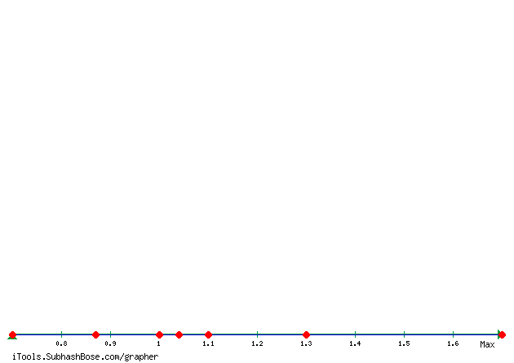

|  |  |  |  |  |  |
| --- | --- | --- | --- | --- | --- |
| # | Question | Mean Importance | Mean Performance | Absolute Diff | Relative Diff |
| 1 | Tickets are fairly priced compared to similar music / food festivals | 4.20 | 3.53 | - 0.67 | 0.84 |
| 2 | Availability and ease of booking additional onsite activities | 3.79 | 3.44 | - 0.35 | 0.91 |
| 3 | Availability of public transport to The Big Feastival | 2.13 | 3.31 | 1.18 | 1.55 |
| 4 | Availability of car parking within easy reach of The Big Feastival site | 4.25 | 4.07 | - 0.18 | 0.96 |
| 5 | Ease of departing The Big Feastival | 4.20 | 3.42 | - 0.78 | 0.82 |
| 6 | Music line-up | 4.30 | 3.62 | - 0.69 | 0.84 |
| 7 | Chef line-up | 3.06 | 3.56 | 0.50 | 1.16 |
| 8 | Children's entertainment | 2.98 | 3.63 | 0.65 | 1.22 |
| 9 | Quality of market and shopping stalls | 3.59 | 3.32 | - 0.26 | 0.93 |
| 10 | Festival setting / venue | 4.17 | 4.47 | 0.29 | 1.07 |
| 11 | Quality of food & drink available | 4.44 | 4.29 | - 0.15 | 0.97 |
| 12 | Baby change and parent facilities | 2.17 | 3.69 | 1.52 | 1.70 |
| 13 | Disabled access and facilities (if applicable) | 2.13 | 3.35 | 1.22 | 1.57 |
| 14 | Personal safety and security on site | 4.41 | 4.07 | - 0.34 | 0.92 |
| 15 | Access to free drinking water | 4.62 | 3.74 | - 0.88 | 0.81 |
| 16 | Cashless payment availability | 3.86 | 3.98 | 0.11 | 1.03 |
| 17 | Availability & cleanliness of shower facilities | 4.38 | 3.09 | - 1.29 | 0.71 |
| 18 | Ability to camp with friends | 4.19 | 3.85 | - 0.34 | 0.92 |
| 19 | Access to campsite | 4.53 | 3.98 | - 0.55 | 0.88 |
| 20 | Campsite staff | 4.05 | 3.74 | - 0.31 | 0.92 |
|  | ***Mean*** | | | ***-0.07*** | ***1.04*** |

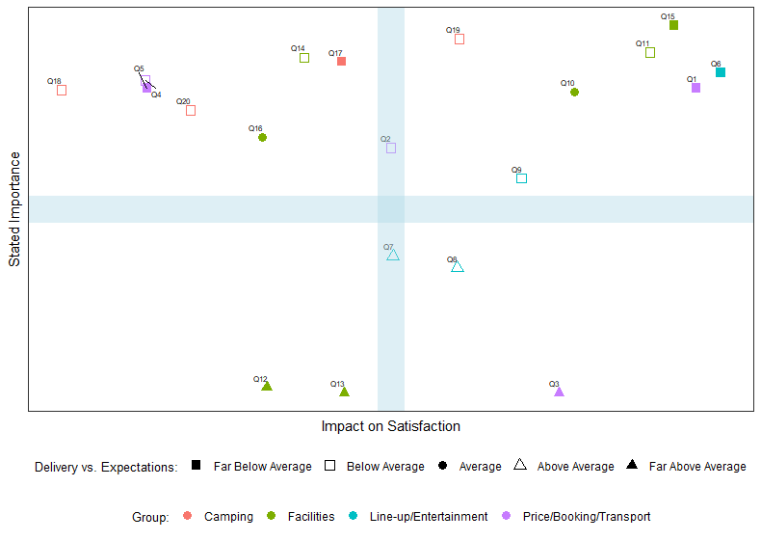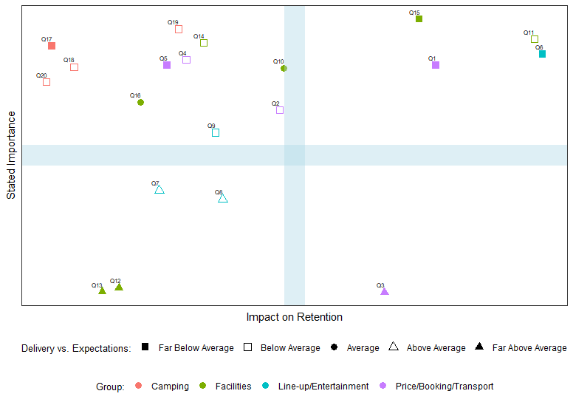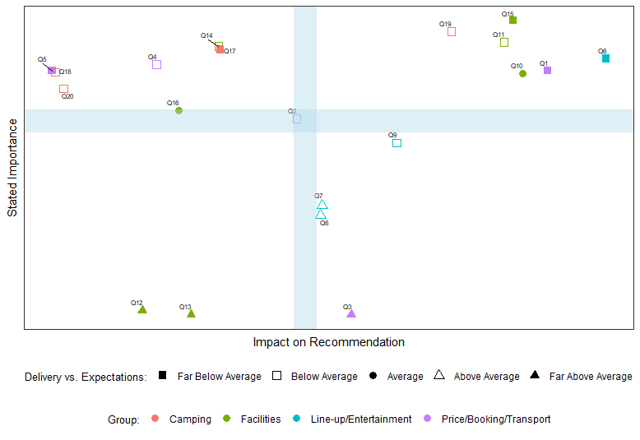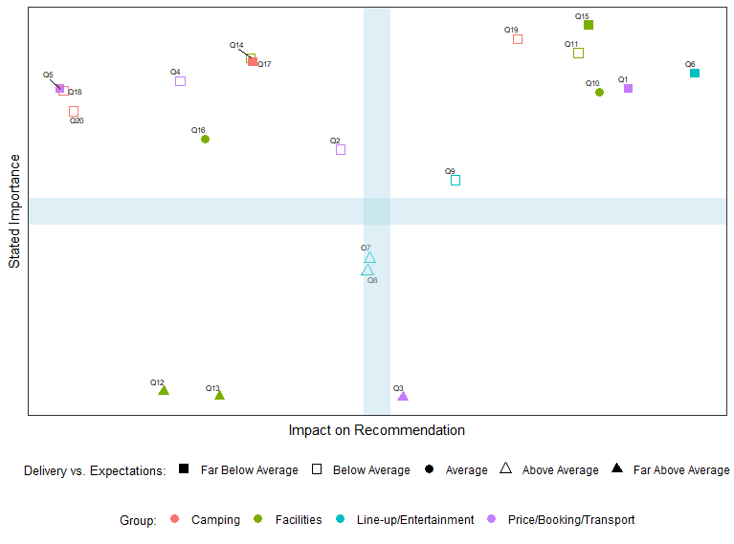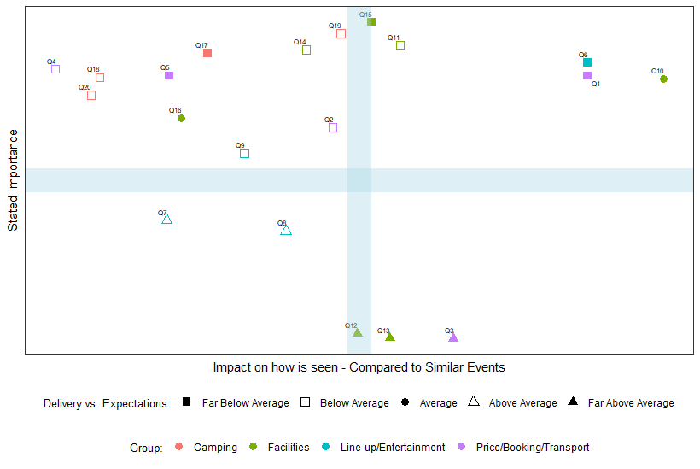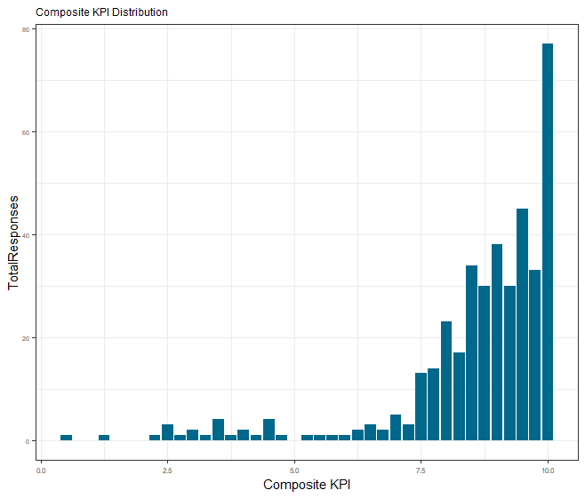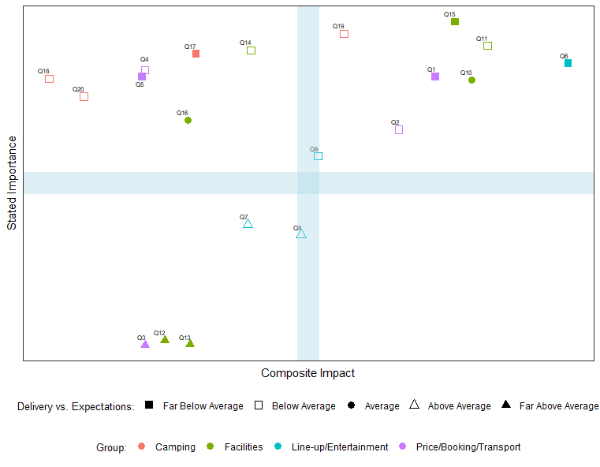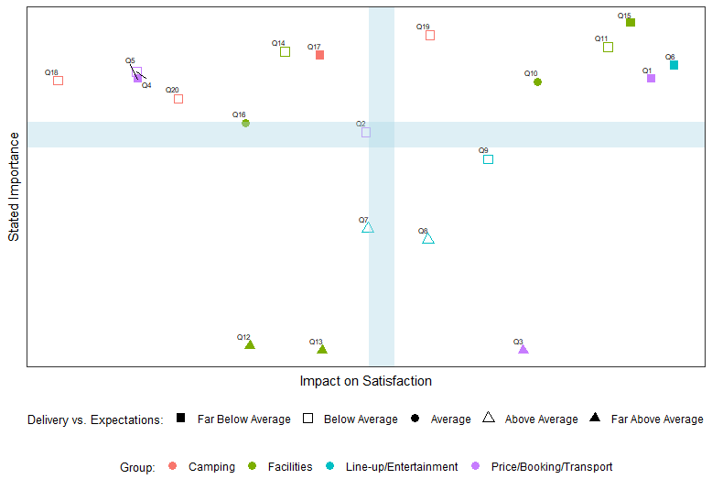

1. 1.00 = 1.04 – 0.034
2. 0.87 = 0.7+5*0.034